Artificial Intelligence
What is Artificial Intelligence?
Artificial Intelligence (AI) is a branch of computer science that focuses on creating machines and computer programs that can perform tasks that normally require human intelligence.
In simple words:
AI makes computers capable of performing intelligent tasks such as:
- Learning from experience.
- Solving problems.
- Making decisions.
Example: When YouTube recommends videos based on your interests, it uses AI to learn from your viewing habits.
What is Intelligence?
Intelligence is the ability to:
- Learn new things.
- Understand information.
- Solve problems.
- Make decisions.
- Adapt to new situations.
- Use knowledge to achieve goals.
Example: A student uses intelligence to understand a question, select the correct method, and solve it.
AI attempts to give computers some of these intelligent abilities.
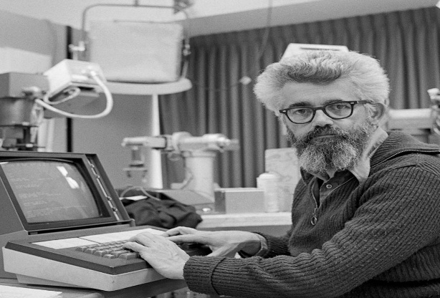
John McCarthy
John McCarthy is known as the Father of Artificial Intelligence.
- He introduced the term Artificial Intelligence in 1956.
- He helped organize the Dartmouth Conference.
- He developed the Lisp programming language
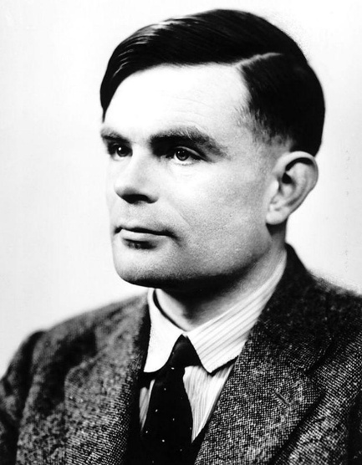
Alan Turing
Alan Turing was a British mathematician and computer scientist.
- He made important contributions to computer science.
- He proposed the Turing Test.
- His work helped develop the idea of machine intelligence.

Turing Test
The Turing Test was proposed by Alan Turing in 1950.
Definition: The Turing Test checks whether a machine can communicate in such a way that a human cannot reliably distinguish it from another human.
How does it work?
- A human judge communicates with two hidden participants.
- One participant is a human.
- The other participant is a computer.
- The judge asks questions through text.
- If the judge cannot reliably identify the computer, the machine is considered to have passed the test.
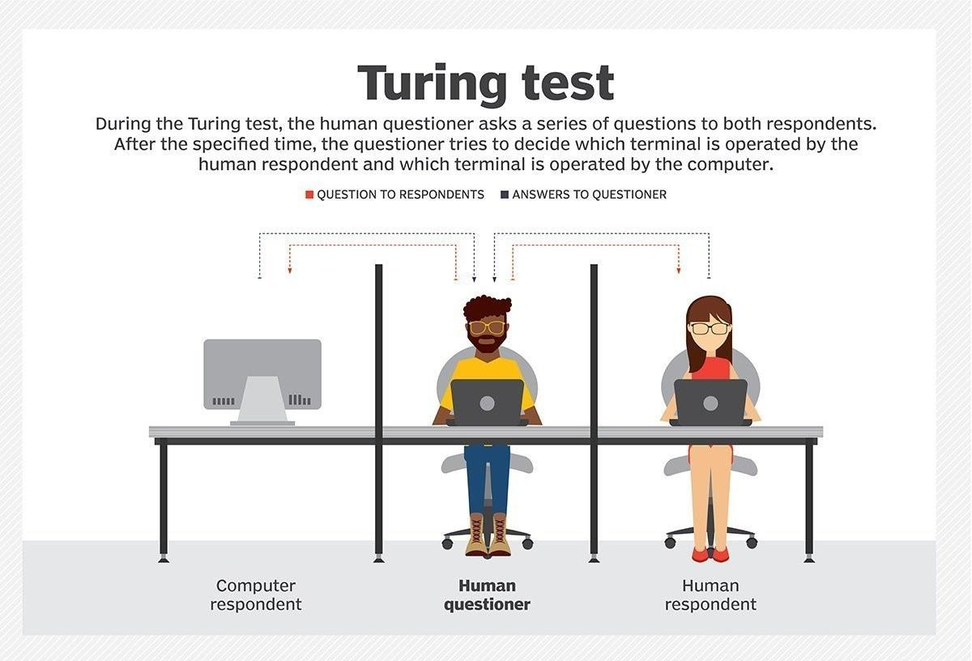
Example: A chatbot answers questions so naturally that the judge cannot tell whether the answers come from a human or a computer.
Important point: The Turing Test evaluates human-like communication, not every aspect of intelligence.

Four Approaches to Artificial Intelligence
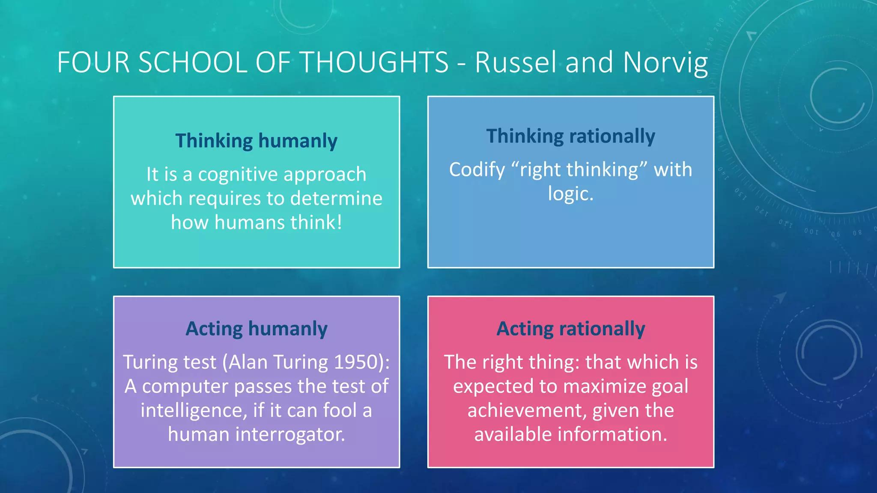
AI can be understood through four major approaches.
1. Thinking Humanly
Making computers think like human beings.
Example: Developing a program that solves a problem using human-like thinking processes.
2. Acting Humanly
Making computers behave like human beings.
Example: A chatbot that communicates like a human.
3. Thinking Rationally
Making computers think logically and reach correct conclusions.
Example: A program that uses logical rules to solve a mathematical problem.
4. Acting Rationally
Making computers choose the best possible action to achieve a goal.
Example: A self-driving car choosing a safe route.

6. Cognitive Science
Cognitive Science is the study of how the human mind works.
It studies mental activities such as:
- Thinking.
- Learning.
- Memory.
- Understanding.
- Decision-making.
- Problem-solving.
AI researchers use ideas from cognitive science to understand how humans think and learn.

Cognitive Modelling
Cognitive modelling means creating computer models that represent how humans think and solve problems.
Example: Creating a computer program that solves puzzles using a process like human reasoning.
How do we know how humans think? Introspection vs. psychological experiments

Introspection
Introspection means examining your own thoughts and mental processes.
Example: A person thinks about how they solved a difficult question.

Psychological Experiments
Psychological experiments are used to study human behaviour and mental processes.
Example: Researchers observe how people remember information or make decisions.

Cognitive Revolution
The Cognitive Revolution was a major change in psychology during the 1950s and 1960s.

Researchers began focusing more on internal mental processes, such as memory, thinking, and learning, rather than only observable behaviour.

Methods of Studying Human Thinking

How can researchers validate their models?
Three methods are important:
1. Top-Down Approach
Starts with a theory or general idea and checks it using specific examples.
Observing human behaviors and building a thinking model based on them.
2. Bottom-Up Approach
Starts by observing individual examples and uses them to develop general ideas.
Directly studying brain and neurological data.
3. Simulation
Uses computer programs to imitate human thinking or behaviour.
Creating a model of human thought on a computer and comparing the results

Laws of Thought
Aristotle attempted to understand and organize correct reasoning and logical arguments.
The Laws of Thought approach focuses on using logical rules to produce correct conclusions.
Example:
- All humans are mortal.
- Ali is a human.
- Therefore, Ali is mortal.
This is an example of logical reasoning.

Limitation of Laws of Thought
Real-world problems are not always simple or certain. Sometimes information is incomplete, and computers must make decisions despite uncertainty.

Rational Agents
Definition: A rational agent is an entity that observes its environment and chooses actions that are expected to achieve the best result.
In simple words, a rational agent tries to choose the best possible action according to its available information and goal.
Example: A self-driving car observes traffic and selects a safe action.
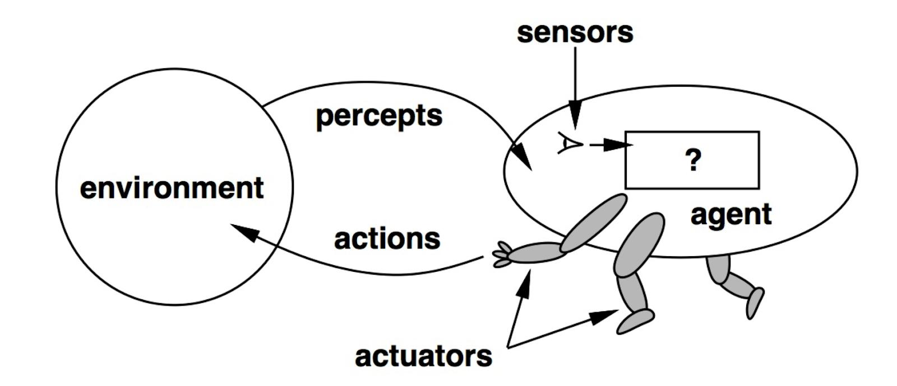Components of a Rational Agent
- Agent: The entity that makes decisions.
- Environment: The surroundings in which the agent operates.
- Sensors: Receive information from the environment.
- Actuators: Perform actions in the environment.
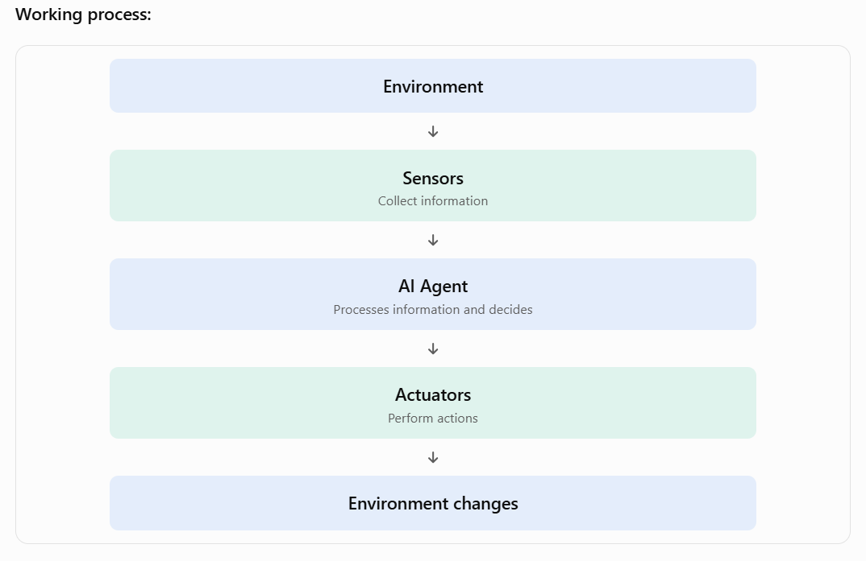

Cognitive Tasks Required for Human-Level Intelligence
To perform tasks similar to humans, AI systems need several abilities.

Natural Language Processing (NLP)
NLP allows computers to understand, process, and generate human language.
Example: ChatGPT understanding a question and providing an answer.

Knowledge Representation
Knowledge Representation means storing information about the world in a form that a computer can use.
Example: A medical AI system stores information about diseases, symptoms, and treatments.

Automated Reasoning
Automated Reasoning allows computers to use stored knowledge and logical rules to reach conclusions.
Example: A system identifies a possible disease using symptoms and medical knowledge.

Machine Learning
Machine Learning allows computers to learn patterns from data and improve their performance without being explicitly programmed for every situation.
Example: An email system learns to identify spam emails.

Includes two issues in Total Turing Test: Computer Vision and Robotics

Computer Vision
Computer Vision allows computers to understand and analyze images and videos.
Example: A system recognizes faces in an image.

Robotics
Robotics involves designing machines that can sense their surroundings and perform physical tasks.
Example: An industrial robot assembling cars.
Important: The Total Turing Test requires additional abilities such as computer vision and robotics, beyond the text-based Turing Test.

Goals of Artificial Intelligence
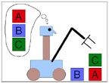
The main goals of AI include:
- To create systems that can learn.
- To solve complex problems.
- To understand human language.
- To make intelligent decisions.
- To perform tasks automatically.
- To develop systems that can reason and plan.
- To improve efficiency and accuracy.

Applications of Artificial Intelligence
AI is used in many areas of life.

Autonomous Planning and Scheduling
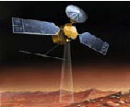AI helps systems plan activities and decide when tasks should be performed.
Examples:
- Planning routes for space rovers.
- Scheduling telescope observations.
- Organizing data analysis tasks.

Medicine
AI helps doctors and medical systems analyze information.
Examples:
- Medical image analysis.
- Image-guided surgery.
- Supporting disease diagnosis.

Transportation
AI helps improve transportation systems.
Examples:
- Self-driving cars.
- Pedestrian detection.
- Traffic management.

Games
AI is used to develop intelligent game opponents.
Examples:
- Chess-playing programs.
- Computer-controlled game characters.

Robotic Toys
AI can make robotic toys respond to their surroundings and interact with people.
Example: A robotic toy that responds to voice commands.

Six Foundations of Artificial Intelligence
AI is based on ideas from six major fields.
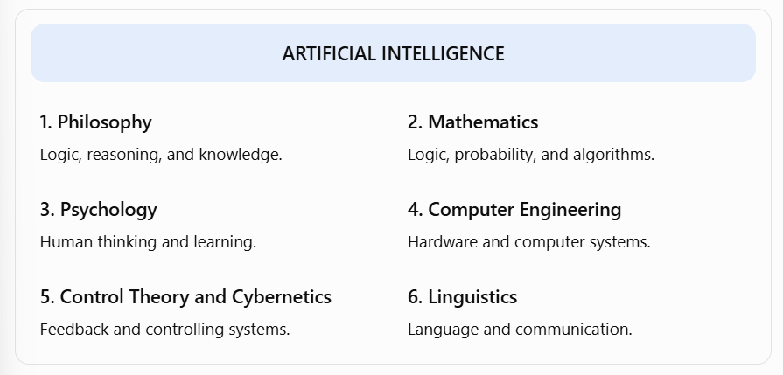
Explanation:
- Philosophy: Provides ideas about thinking, reasoning, and knowledge.
- Mathematics: Provides algorithms, probability, statistics, and logic.
- Psychology: Helps understand how humans learn and think.
- Computer Engineering: Provides the hardware and systems needed to run AI.
- Control Theory and Cybernetics: Studies how systems control actions using feedback.
- Linguistics: Helps computers understand and process human language.

Other Definitions and Purposes of AI
AI has been defined in different ways by different researchers.
The definitions generally focus on:
- Thinking like humans.
- Acting like humans.
- Thinking rationally.
- Acting rationally.

Herbert Simon's Two Purposes of AI
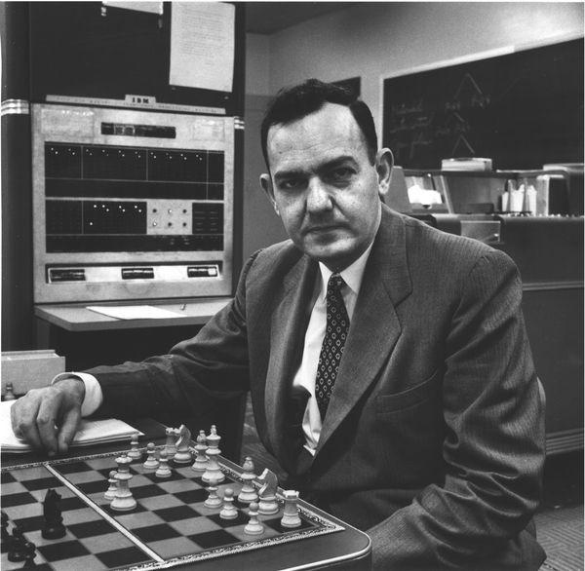
Herbert Simon was an important researcher in AI and decision-making.
Two important purposes associated with AI are:
- Scientific purpose: To understand human intelligence and how people think.
- Engineering purpose: To create intelligent machines that can perform useful tasks.

Easy and Difficult Tasks in AI
Some tasks that seem easy for humans are very difficult for computers.
Usually easy for humans | Often difficult for computers
Recognizing objects | Understanding complex scenes
Walking | Walking on uneven surfaces
Understanding everyday language | Understanding context and meaning
Recognizing faces | Recognizing faces in difficult conditions
Using common sense | Applying common-sense knowledge

Moravec's Paradox
Definition: Moravec's Paradox explains that tasks requiring high-level reasoning can sometimes be easier for computers than basic human abilities such as walking, seeing, and recognizing objects.
Example: A computer can defeat a human in chess, but making a robot walk naturally on uneven ground is much more difficult.

History of Artificial Intelligence
AI developed over many years. Its history is divided into important periods.

Birth of AI (1943–1956)
This period laid the foundation of AI.
Important developments:
- McCulloch and Pitts developed an early mathematical model of artificial neurons in 1943.
- Alan Turing contributed important ideas about machine intelligence.
- Claude Shannon contributed to information theory and computer chess.
- The Dartmouth Conference took place in 1956.
- John McCarthy introduced the term Artificial Intelligence.
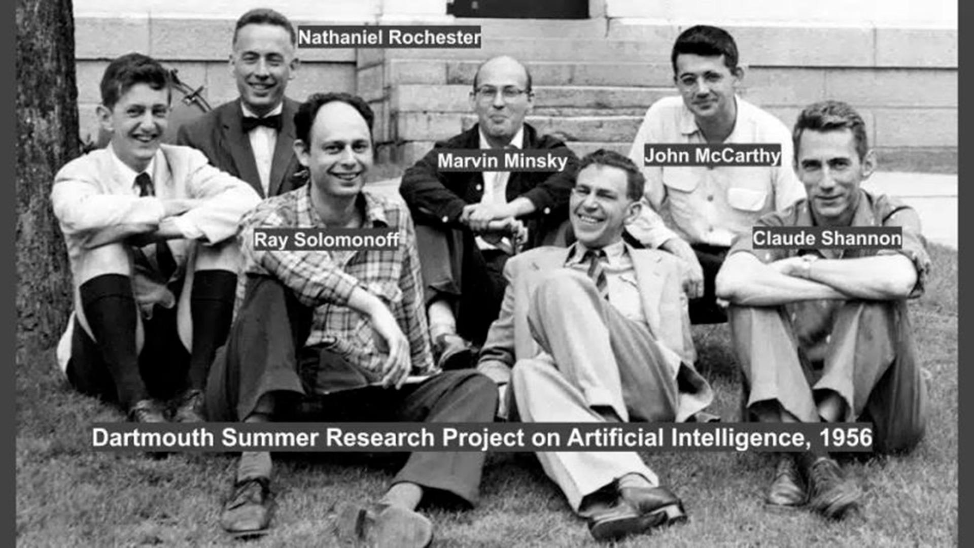
Important: The Dartmouth Conference of 1956 is widely considered the formal beginning of AI as a research field.

Early Enthusiasm (1952–1969)
During this period, researchers were optimistic about AI.
Important developments:
- Early problem-solving programs were developed.
- Newell and Simon worked on the General Problem Solver (GPS).
- John McCarthy developed the Lisp programming language.
- Researchers explored machine reasoning and problem-solving.

Emphasis on Knowledge (1966–1974)
Researchers realized that intelligent systems needed more than simple problem-solving techniques.
They needed:
- More knowledge.
- Better reasoning.
- Information about the real world.
This period increased the importance of knowledge in AI.

Knowledge-Based Systems (1969–1999)
Researchers developed systems that used stored expert knowledge to solve specific problems.
Important systems:
System | Purpose
DENDRAL | Chemical analysis
MYCIN | Medical diagnosis, especially bacterial infections
PROSPECTOR | Mineral exploration
EMYCIN | Expert-system framework developed from MYCIN
Expert System: A computer program that uses stored expert knowledge and rules to solve problems in a particular field.

AI in Industry (1980–1989)
AI started being used in commercial applications.
Important developments:
- Expert systems were used in businesses.
- Companies invested in AI technology.
- AI systems helped solve specialized problems.

Current Trends (1990–Present)
AI became more practical and powerful.
Important areas include:
- Machine Learning.
- Robotics.
- Natural Language Processing.
- Computer Vision.
- Intelligent assistants.
- Autonomous vehicles.
- Deep Learning.
Note: These are the historical periods covered in the previous lecture explanation. The original slide deck is needed to verify any additional dates or events.

AI Winter
Definition: AI Winter refers to a period when interest, funding, and research support for AI decreased because AI systems did not meet high expectations.



Why did AI Winter happen?
- AI systems could not solve many complex real-world problems.
- Computers had limited processing power.
- AI research was expensive.
- Early predictions about AI were too optimistic.
- Some projects failed to produce expected results.
Result: Governments and organizations reduced funding for AI research.
Important exam point: AI Winter does not mean AI completely stopped. It means research funding and interest decreased.

Strong AI and Weak AI
There are two important ideas about machine intelligence.

Weak AI
Definition: Weak AI is designed to perform specific tasks intelligently without having general human-like understanding or consciousness.
Examples:
- Voice assistants.
- Recommendation systems.
- Chess-playing programs.
- Spam filters.

Strong AI
Definition: Strong AI refers to the idea of machines having general intelligence comparable to human intelligence, including genuine understanding.
It is a theoretical concept and has not been achieved as established human-level general intelligence.

Difference Between Strong AI and Weak AI
Weak AI | Strong AI
Performs specific tasks | Aims for general intelligence
Designed for limited purposes | Intended to handle many different tasks
Exists today | Remains theoretical
Example: Chess program | Hypothetical human-level intelligent machine

John Searle and the Chinese Room Argument
John Searle is a philosopher known for the Chinese Room Argument.

Chinese Room Argument
The Chinese Room Argument questions whether a computer can truly understand language or simply follow instructions.

Simple explanation:
- Imagine a person sitting inside a room.
- The person does not understand Chinese.
- They receive Chinese questions.
- They use a rulebook to produce suitable Chinese answers.
- People outside the room may think the person understands Chinese.
- However, the person is only following rules and does not understand the language.
Main idea: Producing correct answers does not necessarily mean that a system genuinely understands their meaning.
Important: This argument is used in discussions about Strong AI and machine understanding.

ELIZA and Chatterbots

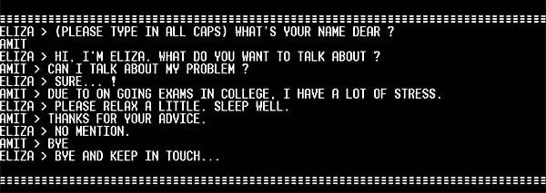

ELIZA
ELIZA was an early chatbot developed by Joseph Weizenbaum in the 1960s.
It simulated conversation by identifying words and using predefined response patterns.
Example:
- User: I feel sad.
- ELIZA: Why do you feel sad?
ELIZA could produce human-like responses without actually understanding the user's feelings.

Chatterbots
A chatterbot is a computer program designed to communicate with users through conversation.
Examples:
- ELIZA.
- ALICE.
- Modern AI chatbots.

ALICE
ALICE stands for Artificial Linguistic Internet Computer Entity.
It was a chatbot that used predefined patterns to generate responses.
Difference:
ELIZA | ALICE
Developed in the 1960s | Developed later, in the 1990s
Early chatbot | More advanced pattern-based chatbot
Used simple response patterns | Used AIML-based patterns

Robots in Artificial Intelligence
A robot is a machine that can perform tasks automatically or with human control.
AI can make robots more intelligent by helping them:
- Understand their surroundings.
- Recognize objects.
- Make decisions.
- Plan movements.
- Perform tasks independently.

ASIMO
ASIMO was a humanoid robot developed by Honda.
Important abilities:
- Walking.
- Running.
- Climbing stairs.
- Recognizing people.
- Interacting with humans.

Domestic Robots
Domestic robots are designed to perform household tasks.
Examples:
- Robot vacuum cleaners.
- Floor-cleaning robots.
- Household assistance robots.

Military Robots
Military robots are used in defence and military operations.
Examples:
- Bomb-disposal robots.
- Surveillance robots.
- Unmanned vehicles.

AIBO

AIBO was a robotic dog developed by Sony.
It was designed to behave like a pet and interact with humans.

21.5 RoboCup

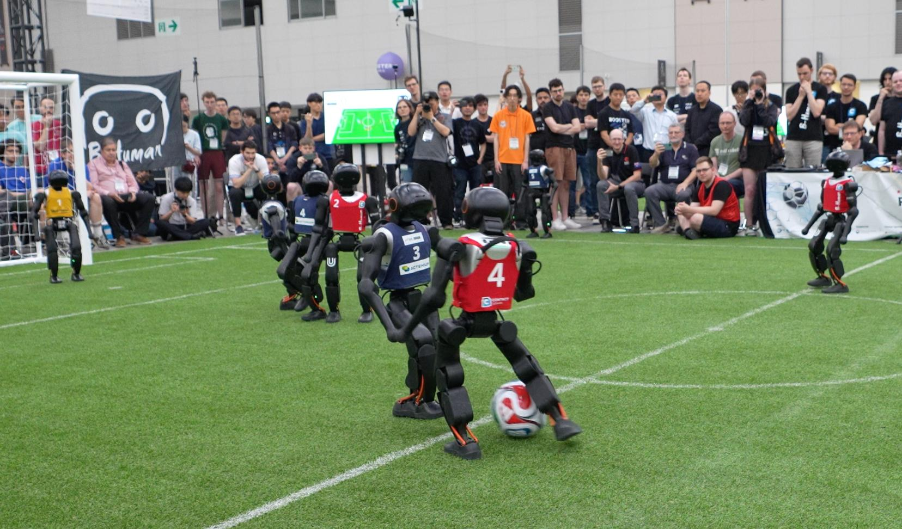
RoboCup is an international robotics competition in which robots participate in soccer and other challenges.
Its purpose includes encouraging research in robotics and AI.

22. Deep Blue and Garry Kasparov
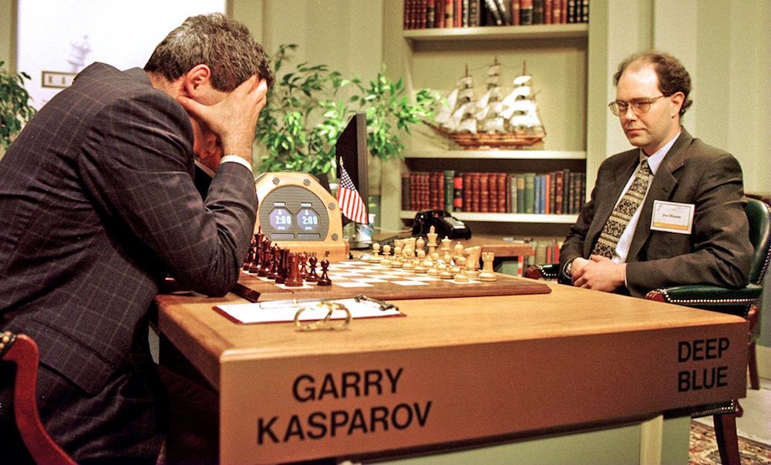
Deep Blue was a chess-playing computer developed by IBM.
Garry Kasparov was a world chess champion.
Important facts:
- In 1996, Deep Blue played a match against Kasparov.
- Kasparov won the 1996 match.
- In 1997, an improved Deep Blue defeated Kasparov in a rematch.
- This was an important achievement in AI history.
Why is Deep Blue important?
It showed that computers could perform extremely well in complex strategic games.

23. IBM Watson
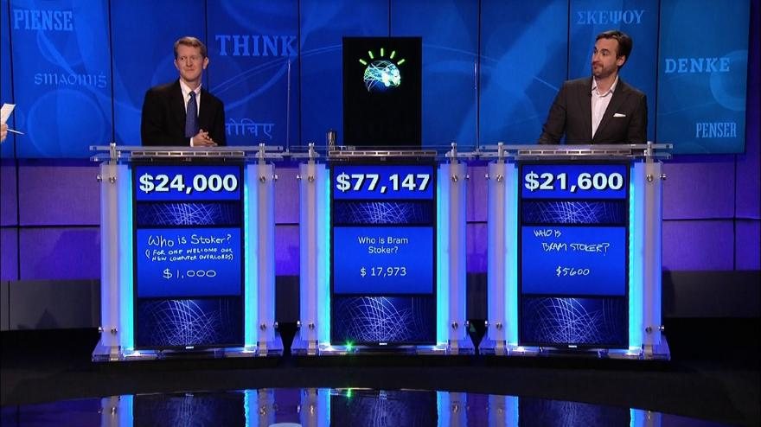
IBM Watson is an AI question-answering system developed by IBM.
It became famous after competing in the television quiz show Jeopardy! in 2011.

Technologies Used in Watson
Watson used several technologies, including:
- Natural Language Processing.
- Information Retrieval.
- Knowledge Representation.
- Machine Learning.
- Automated Reasoning.

7\

How Watson Works

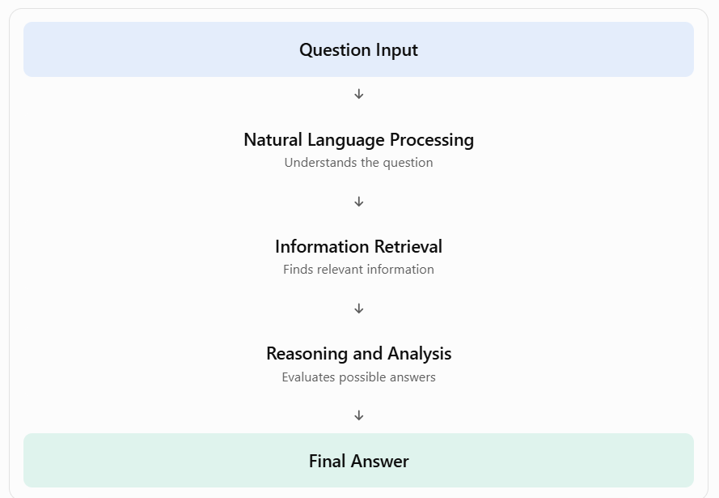

State of the Art in AI
State of the Art means the most advanced level of technology or achievement available in a particular field at a given time.
Examples of AI achievements include:
- Speech recognition.
- Language translation.
- Medical image analysis.
- Autonomous vehicles.
- Robotics.
- Game-playing systems.
- Virtual assistants.
- Recommendation systems.
AI continues to develop, and its capabilities improve as algorithms, data, and computing power advance.

Final Revision: Important Exam Material

A. Important Definitions
Term | Easy definition
Artificial Intelligence | Making machines perform tasks that require intelligence
Intelligence | Ability to learn, understand, reason, and solve problems
Turing Test | Test of whether a machine can communicate like a human
Cognitive Science | Study of how the human mind works
Cognitive Modelling | Creating models of human thinking
Rational Agent | An entity that selects actions to achieve the best result
NLP | Technology that allows computers to process human language
Knowledge Representation | Storing knowledge in a form computers can use
Automated Reasoning | Using logic to reach conclusions
Machine Learning | Learning patterns from data
Computer Vision | Understanding images and videos
Robotics | Designing and using robots
AI Winter | Period of reduced interest and funding in AI
Weak AI | AI designed for specific tasks
Strong AI | The idea of general human-like machine intelligence
Expert System | A program that uses expert knowledge to solve problems
Chatterbot | A computer program that communicates through conversation

B. Important Comparisons
Make sure you can explain these differences in your own words:
- Thinking Humanly vs. Acting Humanly.
- Thinking Rationally vs. Acting Rationally.
- Turing Test vs. Total Turing Test.
- Weak AI vs. Strong AI.
- ELIZA vs. ALICE.
- Biological Approach vs. Phenomenal Approach.
- Sensors vs. Actuators.
- Biological Intelligence vs. Artificial Intelligence.

C. Important People and Their Contributions
Person | Contribution
John McCarthy | Father of AI; introduced the term AI
Alan Turing | Proposed the Turing Test
Herbert Simon | Important work on AI and decision-making
John Searle | Chinese Room Argument
Joseph Weizenbaum | Developed ELIZA
Garry Kasparov | Chess champion who played against Deep Blue
Claude Shannon | Contributions to information theory and computer chess

D. Important Systems and Their Purposes
System | Purpose
GPS | General Problem Solver
DENDRAL | Chemical analysis
MYCIN | Medical diagnosis
PROSPECTOR | Mineral exploration
EMYCIN | Expert-system framework
ELIZA | Early chatbot
ALICE | Pattern-based chatbot
ASIMO | Humanoid robot
AIBO | Robotic dog
Deep Blue | Chess-playing computer
IBM Watson | Question-answering system

